1. The definition of Bell polynomial sequence is defined recursively as follows:

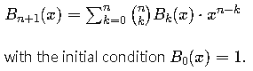

X has a value between [0, 1] with the step 0.004, When the value of n changes from 0 to 3, we can get four curves B1(x) ~ B4(x) as the figure 1.

Hint: $\left({n \atop k}\right)=\frac{n!}{\left(n-k\right)! k!}$

$$\underset{k=0}{\overset{n}{∑}}\left({n \atop k}\right)B_{k}(x)⋅x^{n-k}$$

$$=\left({n \atop n}\right)B_{n}(x)⋅x^{n-n}+\left({n \atop n-1}\right)B_{n-1}(x)⋅x^{n-(n-1)}+⋯+\left({n \atop 1}\right)B_{1}(x)⋅x^{n-1}+\left({n \atop 0}\right)B_{0}(x)⋅x^{n-0}$$

1. Please draw these four curves on the same figure with **different colors and**

**line types**, remember to use the **legend** command to identify each curve.

1. Please get the graphic handle of B3(x), and use it to change the **(i) color,**

**(ii) linewidth, (iii) line type of B3(x).**

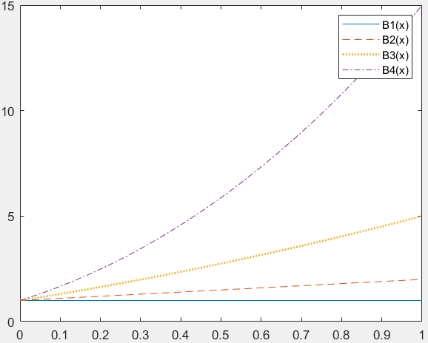

Fig 1.

1. Imagine you have a set of data points representing the temperature at different times of the day. Your goal is to fit a curve (using polynomial of order n, less than 5) to these data points in order to predict the temperature at times between the measured data points. you are given the data:

|  |  |  |  |  |  |  |
| --- | --- | --- | --- | --- | --- | --- |
| X=Time(hours) | 0 | 1 | 2 | 3 | 4 | 5 |
| Y=Temperature(C) | 20 | 25 | 27 | 28 | 27 |  |

1. Use the best fitting with order n, to predict the **value of y given x=3.6.** and find the value of **SSE and R-square**.  
   Hint: Use function fittype() and fit() to find SSE and R-square.
2. Explain the value of SSE and R-square in the Goodness of fit in comments.
3. Use the MATLAB command to draw a surface plot of the following functions:

${Z=2ρ}^{2}\sin{θ}\cos{θ}$, $ρ=\sqrt{x^{2}+y^{2}}$, $θ=\tan^{-1}{(\frac{y}{x})}$.

Where x is equally divided into 21 points between [-2, 2], and y is equally divided into 21 points between [-1, 1], so this surface has 21*21=441 points.

1. Use the given function to write a **MATLAB sub-function** to **Zernike.m**.  
   Hint: Use function atan2() instead of atan().
2. Use the ‘**meshgrid**’ command to build up a meshgrid in the x-y plane.
3. Plot the surface and the mesh of the z(x,y).
4. To **rotate** your surface plot at fix elevation angle at 180/12 degree, and variable azimuth angles between [-180, +180] with the step of 180/10.  
   Hint: Use function view() to rotate the surface.
5. Create a structure “student ” with the field name and the data as follows:

student(1) = struct('name', 'Banny', 'scores', [85,80,92,78]);

student(2) = struct('name', 'Joey', 'scores', [80,85,90,88]);

student(3) = struct('name', 'Betty', 'scores', [88,82,90,80]);

student(4) = struct('name', 'Mary', 'scores', [80,70,92,86]);

(a) get the values of the **scores** of every students

(b) Calculate the **average score** of each student by

Average score=0.25*score1+0.25*score2+0.2*score3+0.3*score4

(c) **Add a field name ‘avg’** for the Average score of the student.

1. Use the MATLAB command [C = readcell(filename)](https://ww2.mathworks.cn/help/matlab/ref/readcell.html#d124e1188084) to read the test_score1.xls file and store the score in a cell matrix then calculate the **mean and standard deviation** of the mid-term and final scores, and plot the distribution of the final score with value between [60 100] with the step 5.  
   Hint: Use function histogram() to plot the distribution of the final score.

Numbers of student with scores in between 60 to 64

